Steps to be follow when salary page coming blank:

- While new configuration many clients facing issue that Salary Fitment page coming blank
This is configuration base page , based on configuration data will get published on salary fitment page

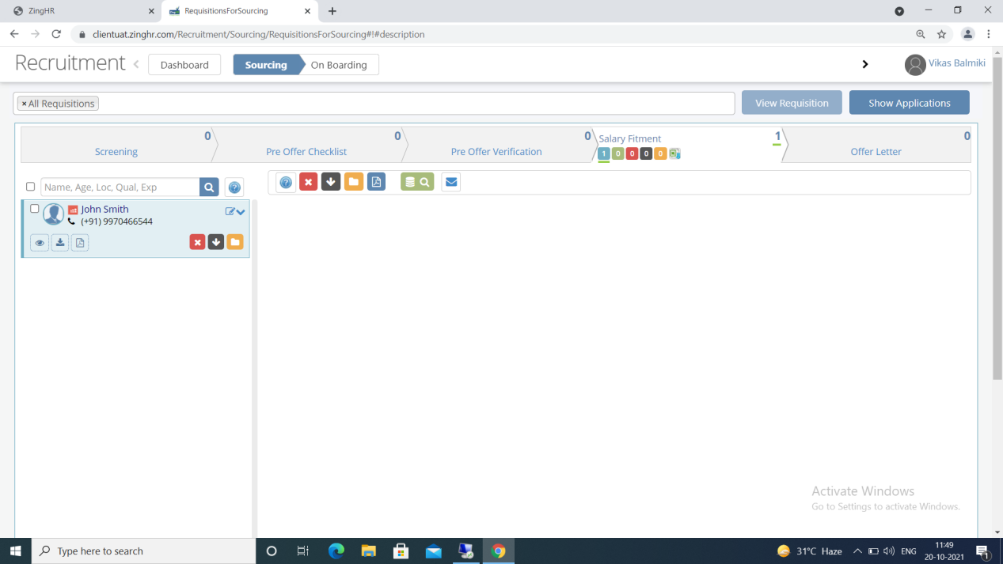

Points to be configured if client opts for CTC BASE salary structure:

- Go to Setup - Compensation And Benefits - select Paygroup (from which candidate belong) - click on Reconfigure button
- COST TO COMPANY (CTC) payhead has to be VALUE and CALCULATION order to be set as 0
- GROSS AMOUNT has to be formula and CALCULATION order to be set highest among all payhead
- BALANCING component has to be formula and do not exclude BALANCING payhead properties form CTC calculation

Points to be check if client opts for GROSS BASE salary structure:

- Go to Setup - Compensation And Benefits - select Paygroup (from which candidate belong) - click on Reconfigure button
- GROSS AMOUNT payhead has to be VALUE and CALCULATION order to be set as 0
- COST TO COMPANY (CTC) has to be formula and CALCULATION order to be set highest among all payhead
- BALANCING component has to be formula and do not exclude BALANCING payhead properties form CTC calculation

