Steps to be follow for making changes in EMAIL TEMPLATE

Go to Setup Circle - E-Recruitment and On-boarding - Email Template

Note : Below steps applicable o all Email template below is an example for format understanding

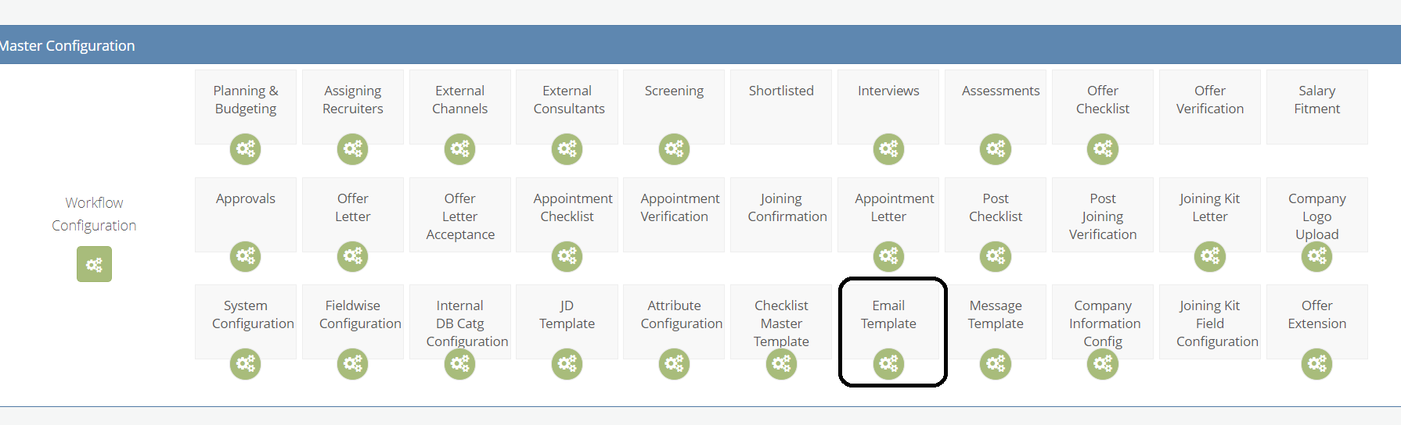

Below image is an Old Format , highlighted part user want to changes with desired text so they can do the same from front end

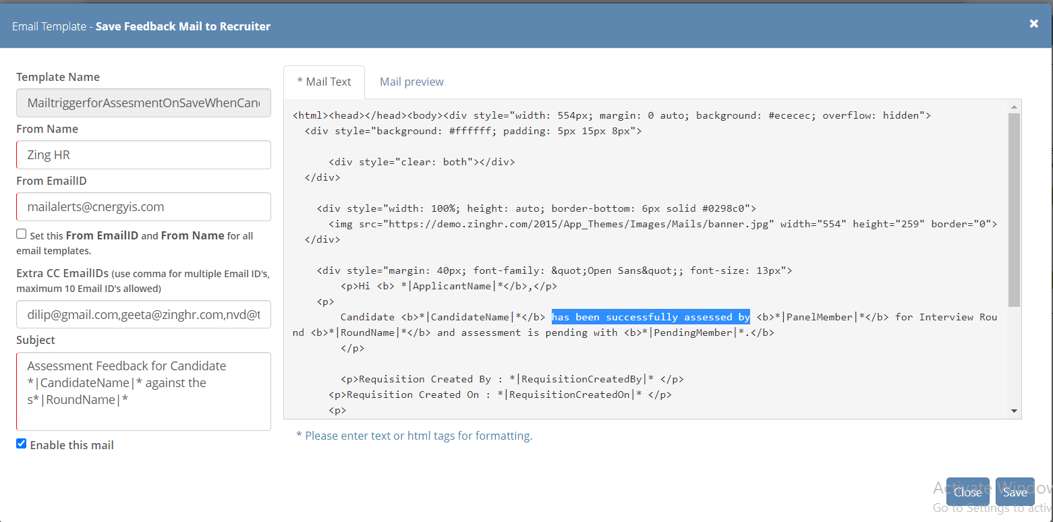

Below Image is post making changes in Email template check the highlighted content

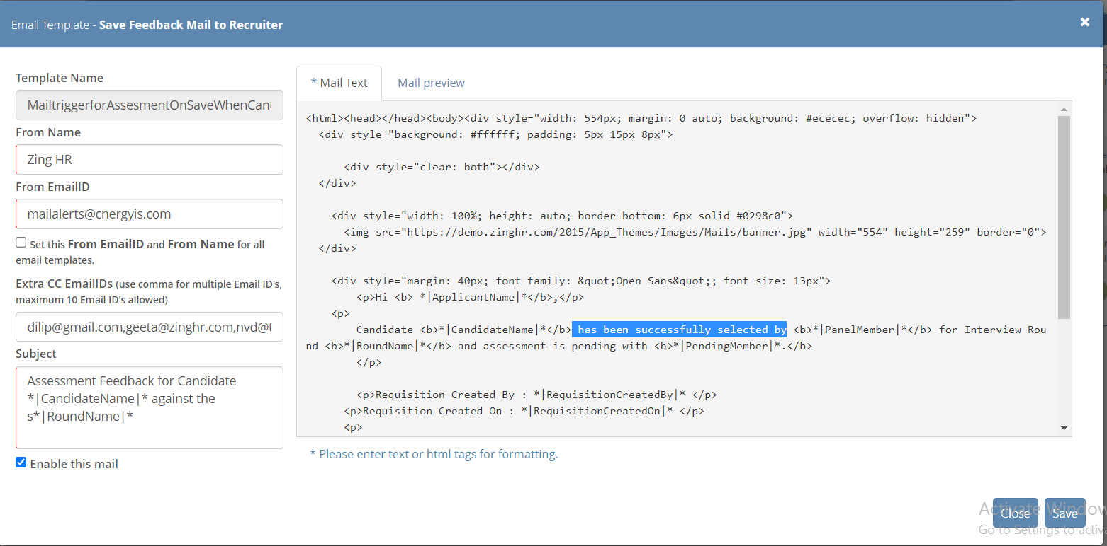

To apply changes click on SAVE
Email preview is given to check changes done by user before using this template in routine by user

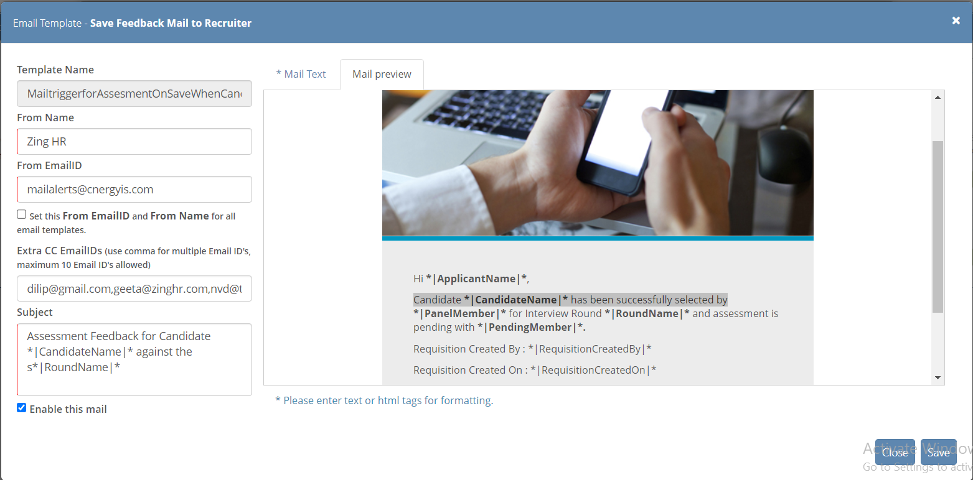

Frequently asked questions about Email Template :-

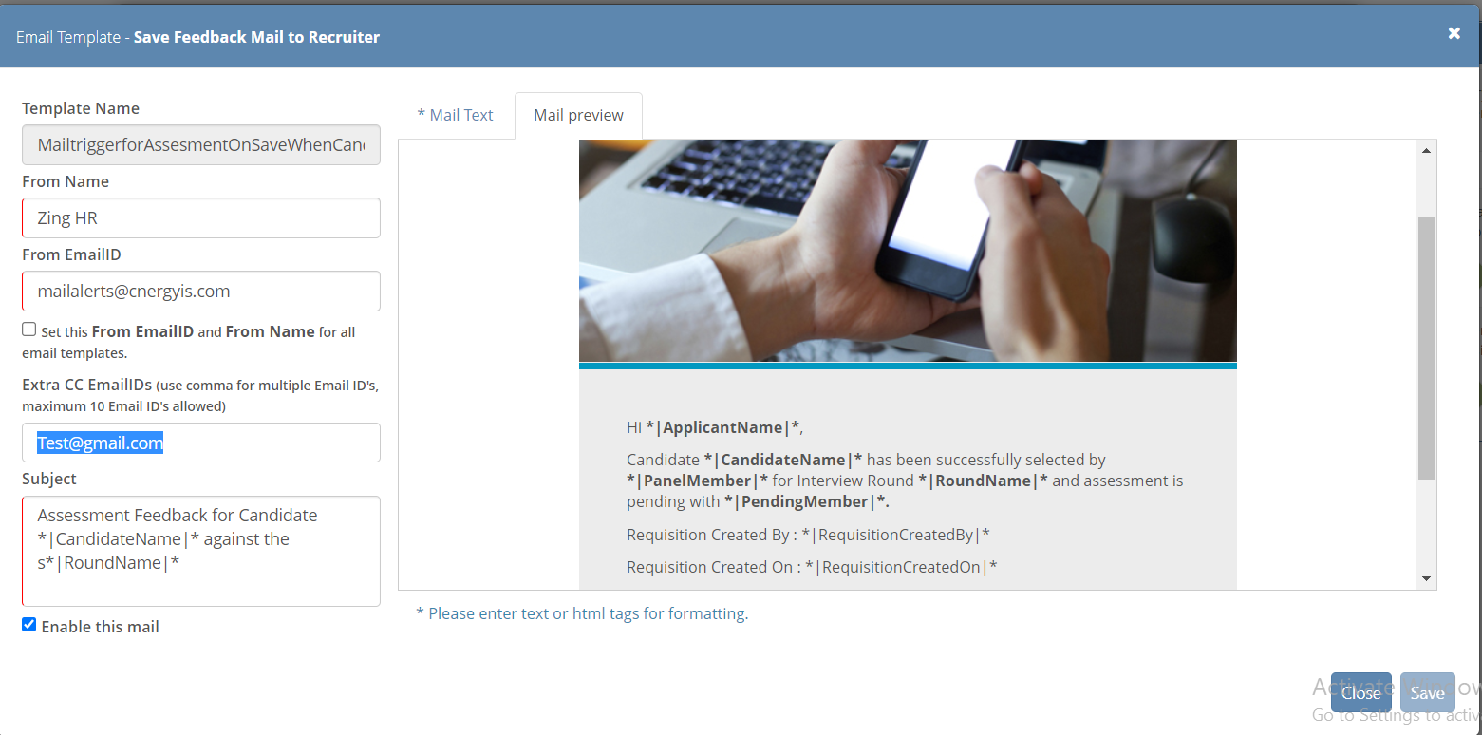

How many EMAIL ID we can add in CC EMAIL SECTION :
Except Panel Member, HR, Reporting Manager, Recruiter , Signing Authority
If user want to send mail to other Employees then CC EMIAL option available in front end
Here, user can add upto 10 EMAILID
This feature is available for all email template.

Can we make changes in FROM EMAIL ID : -

NO, we can no make changes in From Email ID.
It IS REGISTERED ON ZINGHR name .

