Process to enable E-Sign , Video Conference and Scribble Signature

For On-boarding Mobile application, E-sign, Video Conference and Scribble Signature feature when Candidate 1st login to on-boarding Mobile app while accepting Offer Letter or Appointment letter

Earlier it is having Dependency on Back -end to enable those flag

Now we have add those flag in front-end

Follow below process to enable flag :

Go to Setup --> e-Recruitment and On-boarding --> System Configuration

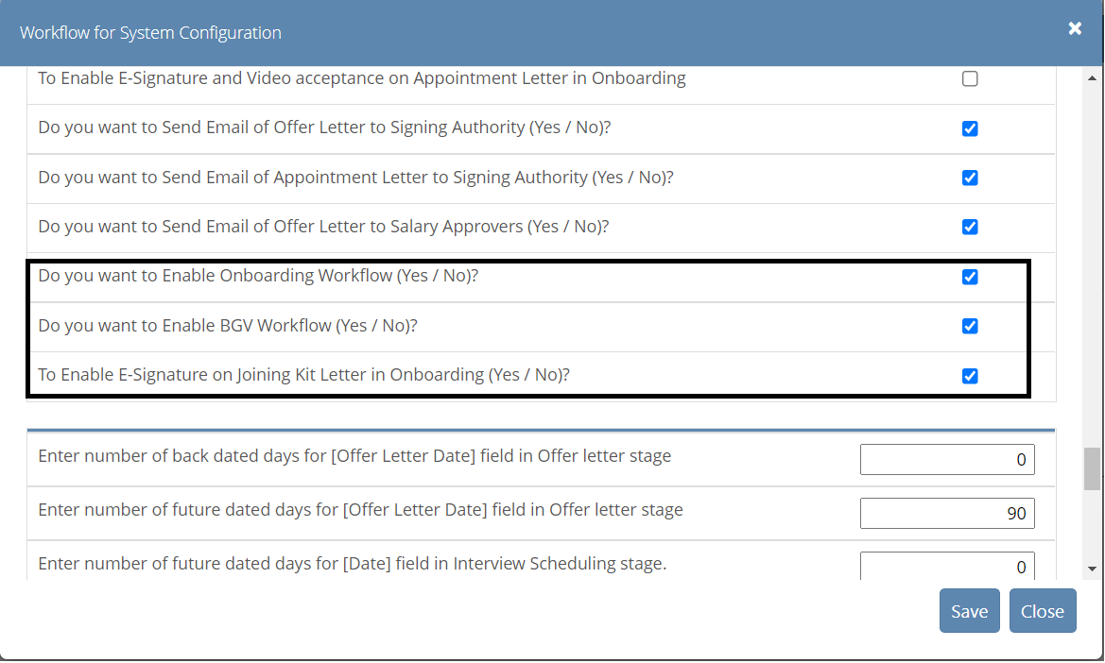

Do you want to Enable Onboarding Workflow (Yes / No)?

- To enable E-sign and Video option while accepting Offer letter and Appointment Letter

- Note : either both can be enable or disable at the same time

To Enable E-Signature on Joining Kit Letter in Onboarding (Yes / No)?

- To enable Scribble sign on Joining kit

- Use below tag while merging Scribble sign in letters:

For Offer Letter :-
«TableStart:Signature»«Image:OfferSignature»«TableEnd:Signature»

For Appointment Letter :-
«TableStart:Signature»«Image:AppointmentSignature»«TableEnd:Signature»

For Joining Kit :-
«TableStart:Basic»«Image:JoiningSignature»«TableEnd:Basic»

