Interview Process Type and Description

We have 3 Interview type which selected during Requisition Creation based on that Interview Process aligned to the Candidate belongs to the Requisition

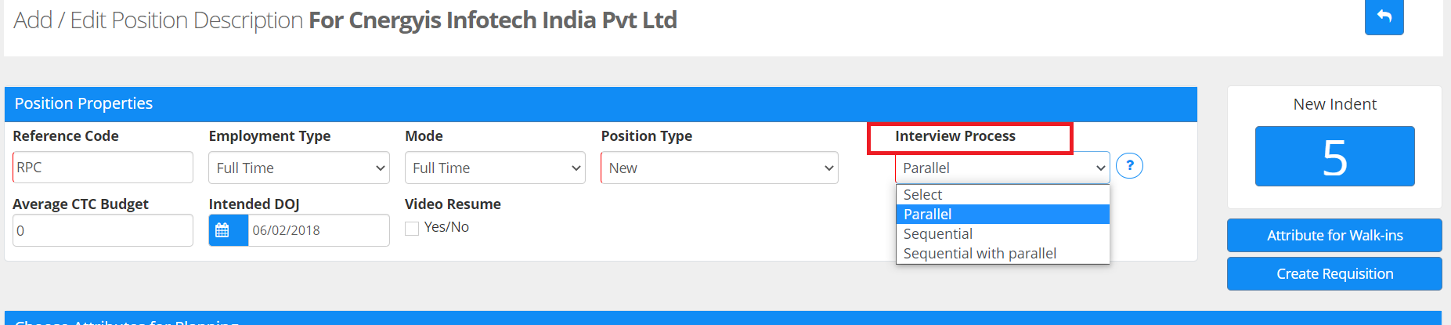

We have 3 Major Interview type are as below :

- Parallel Interview Process :
This workflow is for those scenarios where in all the rounds are not to be taken but some specific rounds are schedule and post the assessment if the assessor has choosen the final opinion option and based on the action the candidate is processed.

- Sequential Interview Workflow:
Based on company interview rounds all rounds are to be scheduled in one time and feedback will be given post that in sequence of the interview rounds created
Sequential workflow will not be able to skip any of the sequence for the candidates

For this type only you will get this link option on which user name is specify who is selected for next round
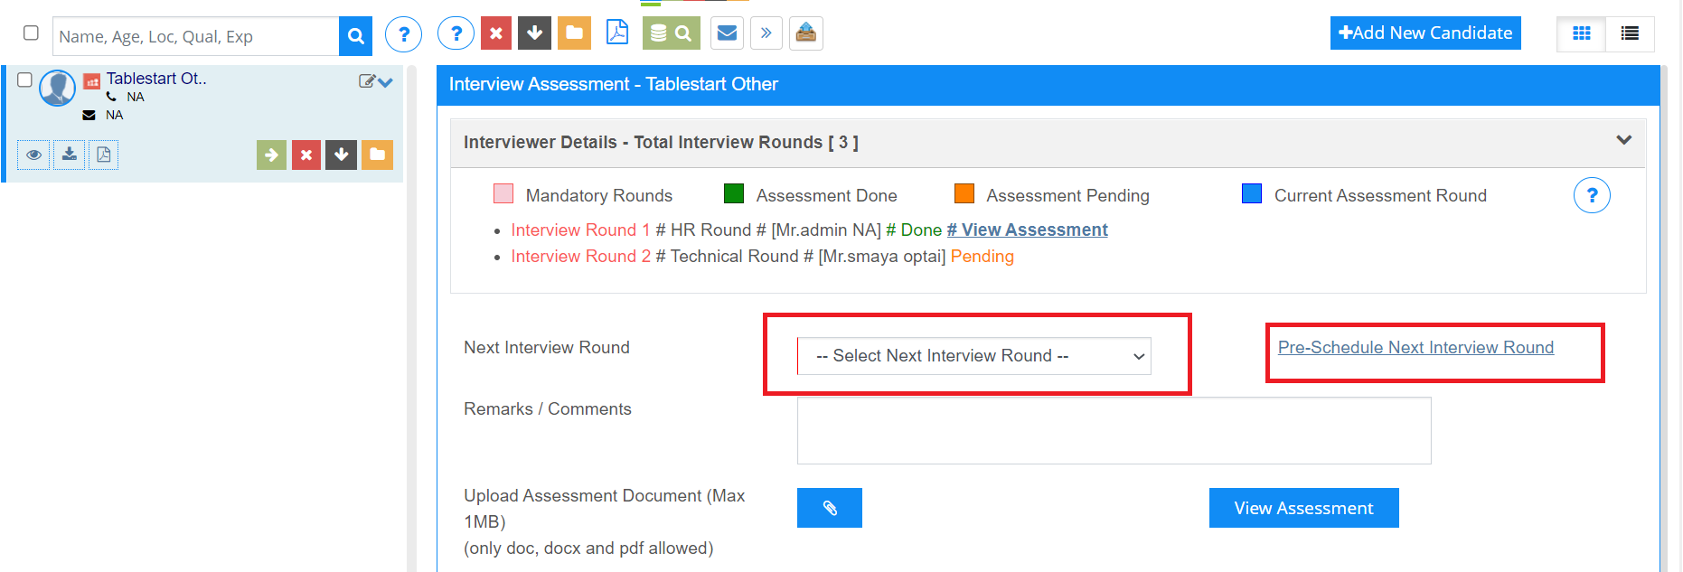

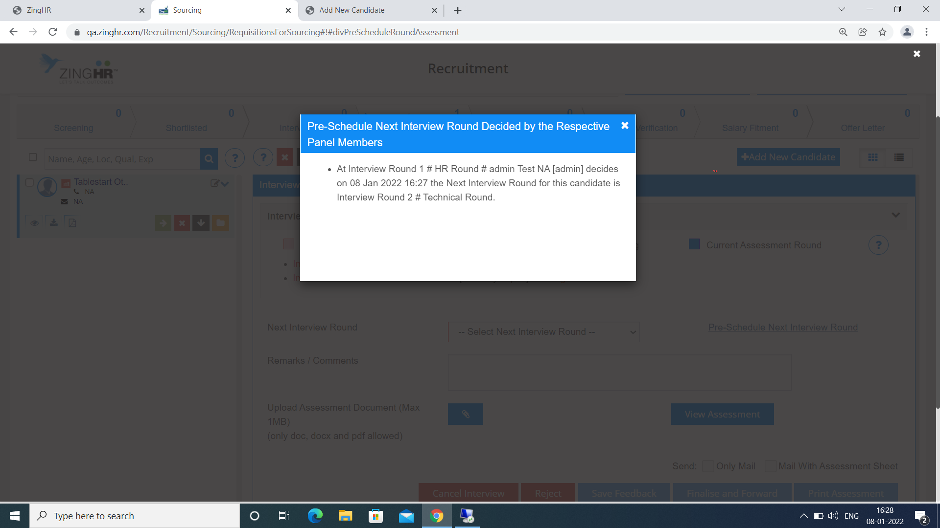

3 . Sequential Interview Workflow:

Based on company interview rounds all rounds are to be scheduled in one time and feedback will be given post that in sequence of the interview rounds created
Sequential workflow will not be able to skip any of the sequence for the candidates

