Packet wise Planning -Budgeting and Talent Acquisition Configuration

This feature used to Restricted user to check only Assigned combination data or only attribute data he/she belongs to.

Eg. :- If User1 allow to check data only for Maharashtra state then with uses of packet definition feature we can assignee only require attribute to the user so that no other state data visible on his/her Dashboard

Go to Setup --> E-Recruitment and On-boarding --> System configuration

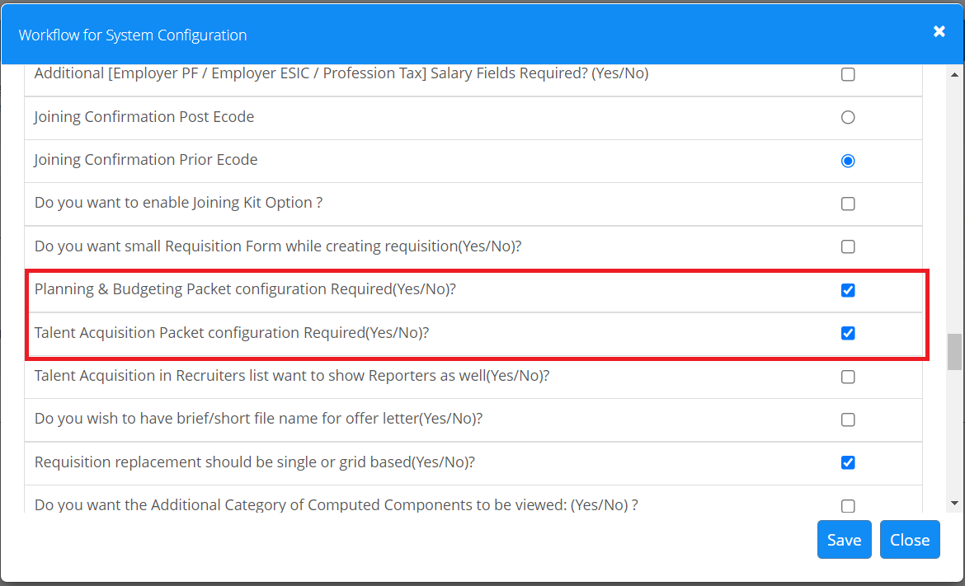

There are different setup for Planning- Budgeting and Talent Acquisition

How to configure Planning and Budgeting packet wise :

Go to setup --> Organisation --> Packet Definition -> Screens

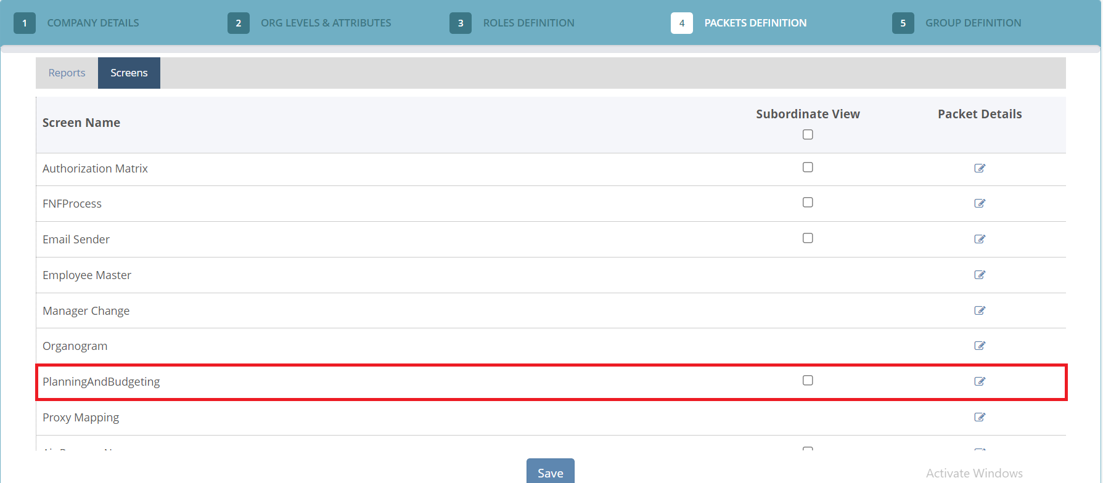

Note : Packet configuration of PNB has to be done on same attribute on which Planning and budgeting configuration is done in Recruitment screen

Go to Setup --> Oragnisation --> Packet Definition --> Screens --> Planning and Budgeting --> Fill the details against Employee code

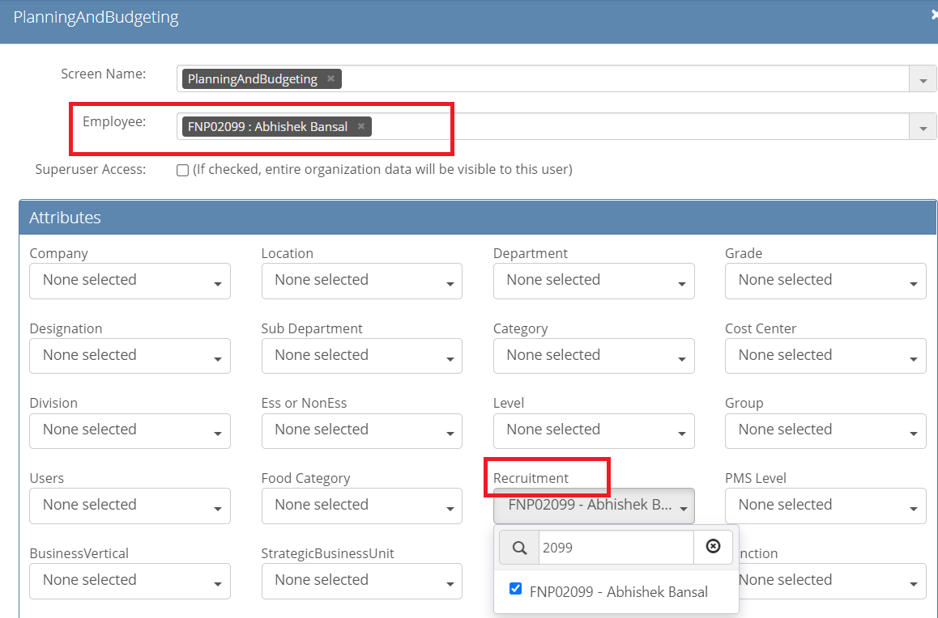

If you see it is Mandatory to configured on Same attribute which you have select in Recruitment screen then only data will publish as per assigned packet

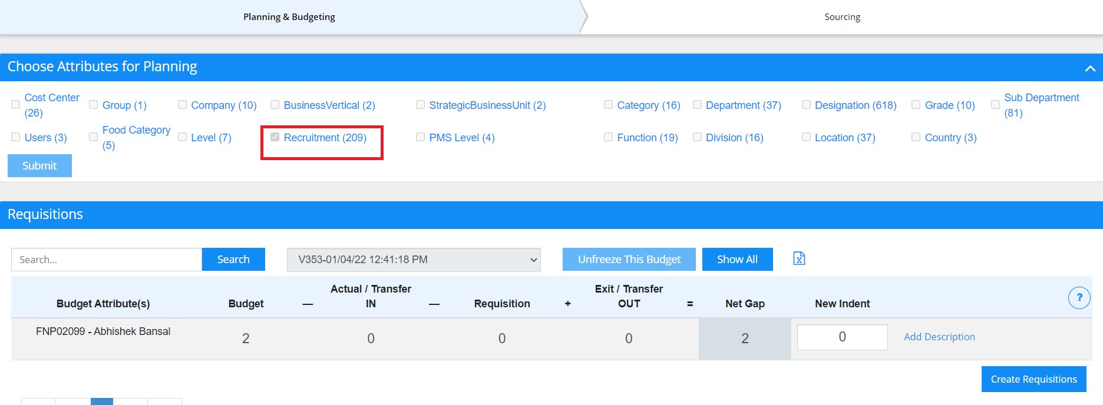

How to configure Talent Acquisition packet wise :

Go to setup --> Organisation --> Packet Definition -> Screens -- Talent Acquisition -->Fill the details

There is no completion on Talent screen to configured on Specific attribute user can configured any random attribute also

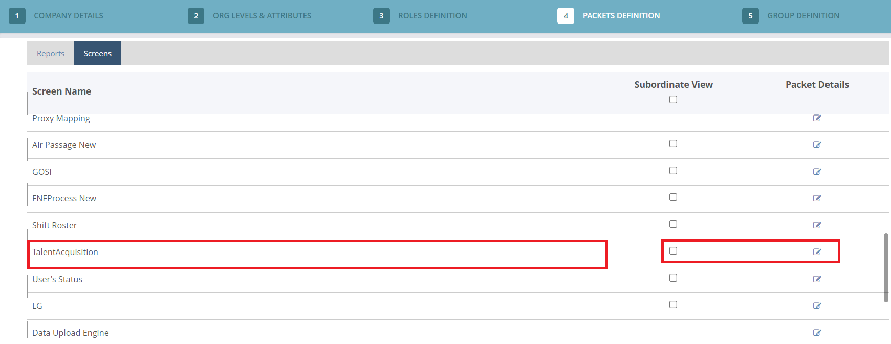

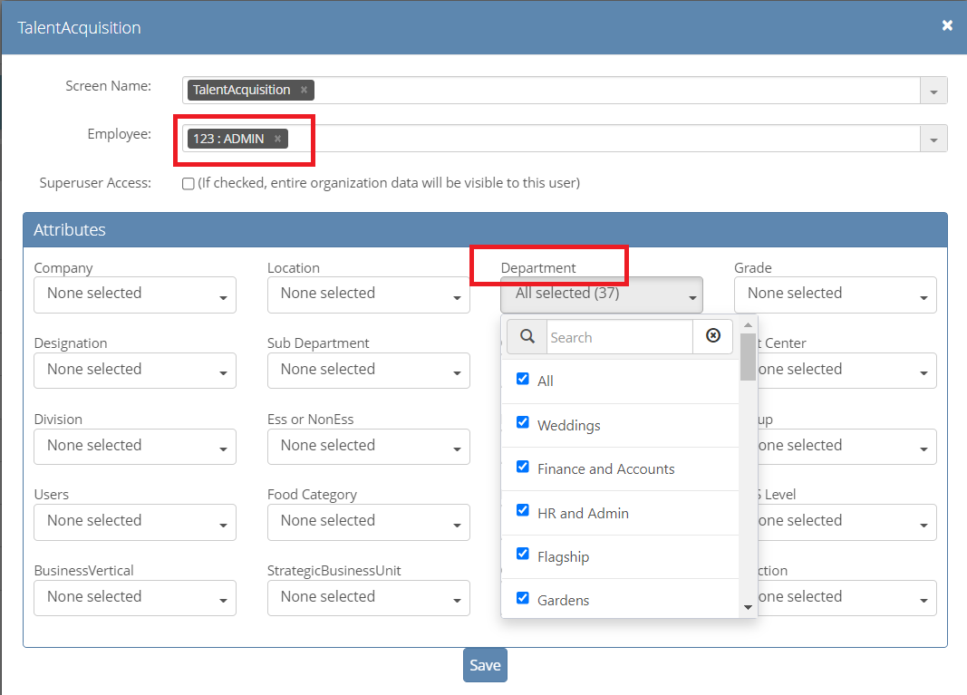

Note : If any changes in assigned attribute against Employee instead of creating new you can Edit the current setup or Delete the current assigned packets and then add new one

