Feature to process salary fitment with Decimal Values :

Earlier even if Salary process with Decimal values in Salary fitment while creating Employee code Round OFF values been pass to the Payroll section
Due to some restriction we are passing only Round Off values for the payroll processing

We have release new feature with that configuration user can decide whether they want to add Decimal in payroll processing or not

Follow below steps to Enable Decimal Configuration :

Go to Setup Circle --> E-Recruitment & On-boarding --> System configuration

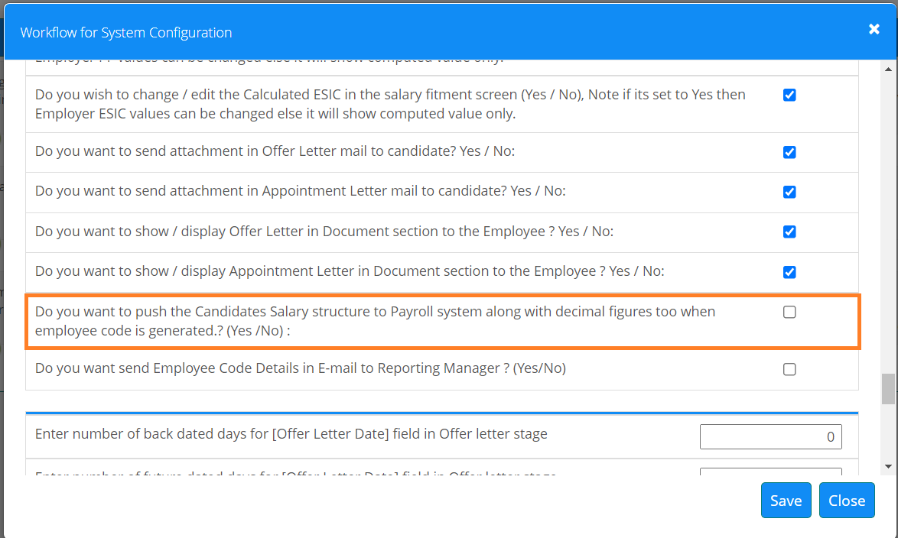

Note : Impact will visible post salary processing from payroll section

