ZingHR - Azure AD SSO Integration with Azure AD SAML Toolkit

Add Azure AD SAML Toolkit from the gallery
To configure the integration of Azure AD SAML Toolkit into Azure AD, you need to add Azure AD SAML Toolkit from the gallery to your list of managed SaaS apps.
- Sign in to the Azure portal using either a work or school account, or a personal Microsoft account.
- On the left navigation pane, select the Azure Active Directory service.
- Navigate to Enterprise Applications and then select All Applications.
- To add new application, select New application.
- In the Add from the gallery section, type Azure AD SAML Toolkit in the search box. Select Azure AD SAML Toolkit from results panel and then add the app.

Configure Azure AD SSO
Follow these steps to enable Azure AD SSO in the Azure portal.
- In the Azure portal, on the Azure AD SAML Toolkit application integration page, find the Manage section and select single sign-on.
- On the Select a single sign-on method page, select SAML.
- On the Set up single sign-on with SAML page, click the pencil icon for Basic SAML Configuration to edit the settings.

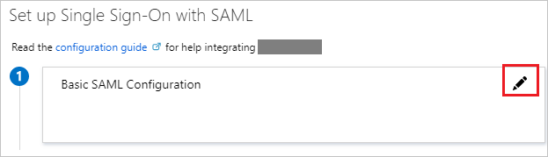
- On the Basic SAML Configuration section, perform the following steps :
Note : Below mentioned URLs are case sensitive, Replace the {{CompanyCode}} placeholder with your actual company code and should be in lowercase
- In the Reply URL text box, type the below URL :
UAT : https://clientuat.zinghr.com/SAML/Pages/Callback.aspx?sub={{CompanyCode}}
Production : https://portal.zinghr.com/SAML/Pages/Callback.aspx?sub={{CompanyCode}}
- In the Sign on URL text box, type the URL :
UAT : https://clientuat.zinghr.com/SAML/Auth/Signin/{{CompanyCode}}
Production : https://portal.zinghr.com/SAML/Auth/Signin/{{CompanyCode}}

- Set name if format to email address :
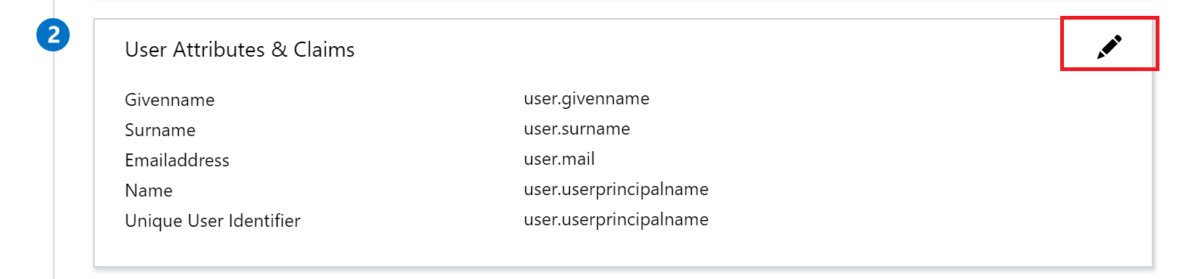
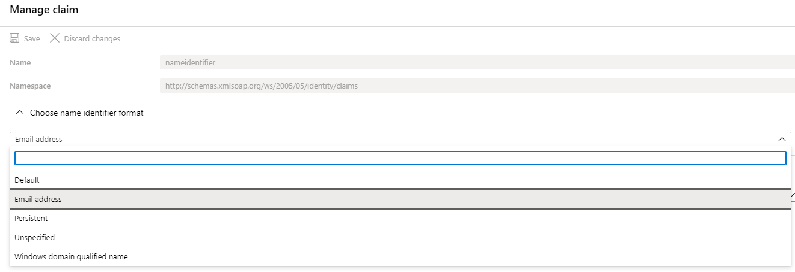
- On the Set up single sign-on with SAML page, in the SAML Signing Certificate section, find Certificate (Base64) and select Download to download the certificate and save it on your computer.
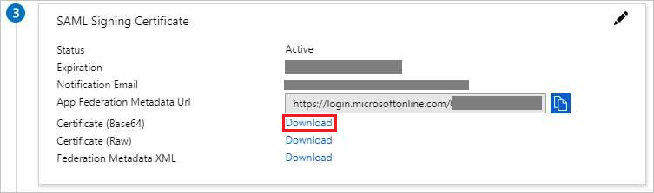
- On the Set up Azure AD SAML Toolkit section, copy the below URL(s)
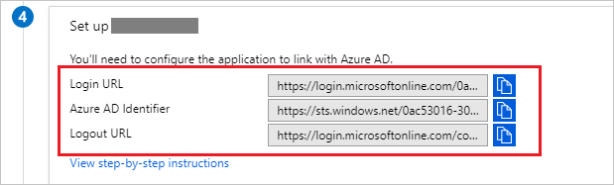
- Share downloaded Certificate, Copied URL(s) and List of EmployeeCodes with NameIds with ZingHR Administrator to configure your app and user assignment in ZingHR system.

Assign the Azure AD User
In this section, you'll enable B.Simon to use Azure single sign-on by granting access to Azure AD SAML Toolkit.
- In the Azure portal, select Enterprise Applications, and then select All applications.
- In the applications list, select Azure AD SAML Toolkit.
- In the app's overview page, find the Manage section and select Users and groups.
- Select Add user, then select Users and groups in the Add Assignment dialog.
- In the Users and groups dialog, select the desired user from the Users list, then click the Select button at the bottom of the screen.
- If you are expecting a role to be assigned to the users, you can select it from the Select a role dropdown. If no role has been set up for this app, you see "Default Access" role selected.
- In the Add Assignment dialog, click the Assign button.

After completing all the configuration and user mapping in Azure Active Directory and ZingHR system please use below link to login to ZingHR Portal using Azure AD credentials.

UAT : https://clientuat.zinghr.com/SAML/Auth/Signin/{{CompanyCode}}
Production : https://portal.zinghr.com/SAML/Auth/Signin/{{CompanyCode}}

Users can also access ZingHR portal from O365, Please refer below screenshot
